Portfolio Project

**FIN 810: Finance Analytics**

22 June 2019

**Contributors:**

Edith Cabrera

Priya Darshini

Divya Mishra

Amber Yao

Table of Contents

Investment Strategy 3

Diversification Efforts 3

Stock Portfolio 4

*Adobe (ADBE)* 4

*JP Morgan (JPM)* 4

*Starbucks (SBUX)* 5

*Beyond Meat (BYND)* 5

*Pinterest (PINS)* 5

Portfolio Analysis 5

Daily Statistics 5

CAPM 6

Fama french 5 Factor Model 6

Safety First Ratio & Sharpe Ratio 7

Best/Worst Performing Stocks 7

Market Anomalies 8

January Returns - ADBE 8

Portfolio Optimization 9

Global Minimum Variance 10

Tangent Portfolio 10

Efficient Frontier 11

Reflection 11

References 12

## 

## Investment Strategy

Our initial investment strategy was to be mostly conservative - taking what we consider to be a risk on only 20% of our purchases - and to hold onto some of our money in cash. Most of our stocks were from well-established technology companies with low risk but also a low growth potential. This was meant to keep us from losing too much of our money, though they may not net us a lot of profit. The 20% of risk was from a stock with a very short history because it recently IPO'd. For our initial buy we chose Lyft because we believed both the industry and company had a lot of potential to do well and soon. Leaving cash available gave us some flexibility in being able to quickly buy more of any stocks that were doing well.

## Diversification Efforts

At the start of this project, our portfolio was made up of only Large Cap companies. Over the course of the ten weeks, we bought and sold based on what we had heard in the news and seen from Yahoo Finance. We wanted to invest in different sectors and companies so that we could hopefully minimize market risk.

Salesforce and Lyft were replaced very early on because they were consistently not performing well in the short term. We replaced Salesforce with ANI Pharmaceuticals, a small cap stock because their earnings were expected to increase 18% this year due to business deals they were making. We had originally replaced Lyft with Chegg because Chegg had been doing consistently well. While our Chegg stock technically was the best stock to invest in, having the highest Sharpe and Safety-first ratios of our portfolio, in the short term it was very volatile and was losing a lot of money.

Of our original portfolio, we retained three stocks for the entirely of the project. Our ultimate portfolio consisted of three technology stocks, one finance stock, and one consumer goods stock. The stocks that we believed to be the riskiest were the two recent IPOs, Beyond Meat and Pinterest. Both of these stocks went public within the last three months and 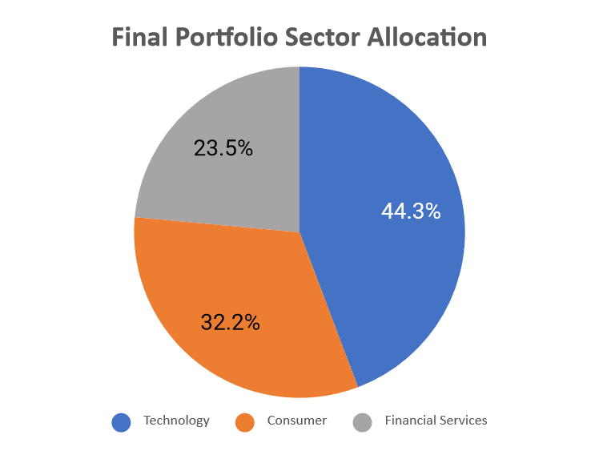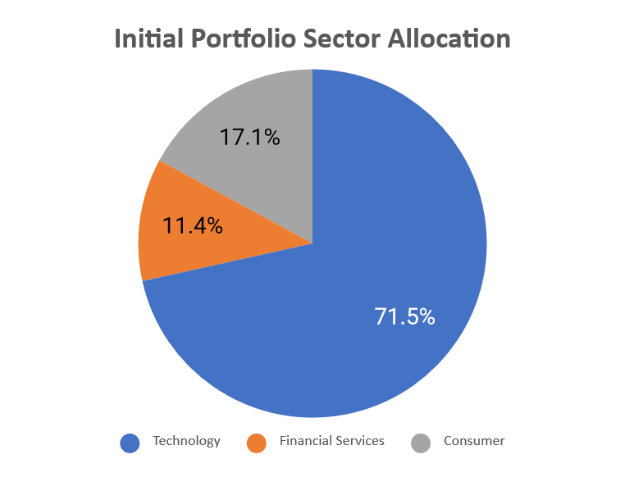changed our initial make-up of 20% risky stocks to 30% risky stocks.

## Stock Portfolio

|  |  |  |  |  |  |
| --- | --- | --- | --- | --- | --- |
| Company | Ticker | # Shares | Price Paid ($) | Purchased Amount ($) | Allocation % |
| Adobe | ADBE | 88 | 273.62 | 24,078.56 | 25.38% |
| Beyond Meat | BYND | 114 | 102.49 | 11,683.86 | 12.32% |
| JP Morgan | JPM | 196 | 113.48 | 22,242.08 | 23.45% |
| Pinterest | PINS | 694 | 25.86 | 17,946.84 | 18.92% |
| Starbucks | SBUX | 246 | 76.85 | 18,905.10 | 19.93% |

### *Adobe (ADBE)*

Adobe is one of the largest diversified software companies in the world. Public trading began on August 20, 1986. Today, the company is mostly focused on creating multimedia software products but are now also expanding towards digital marketing media software. Its products include Adobe Document Cloud, Adobe Creative Cloud, and Adobe Experience Cloud1.

### *JP Morgan (JPM)*

J.P. Morgan Chase & Co. is an investment bank and financial services company. The consumer portion of the company operates under the Chase name and branding. Its offerings include personal and business banking, credit cards, and loans. JP Morgan is the name under which they perform asset management as well as personal and investment banking2. S&P named it as the 6th largest bank by total assets in the world in 20183.

### *Starbucks (SBUX)*

Starbucks is a producer, marketer and retailer of coffee. This company operates in North America/Latin America, China/Asia Pacific, and Europe/Middle East/Africa. Included in its brand portfolio are Starbucks Coffee, Seattle’s Best Coffee, Teavana, Tazo, Evolution Fresh, La Boulange, Ethos Water and Torrefazione Italia Coffee. Worldwide they have 22,519 stores as of June 15, 20184.

### *Beyond Meat (BYND)*

Beyond Meat is a plant-based meal alternative company. Their products can be found at Whole Foods, TGIF, and an increasing number of fast food chains. It filed for IPO on May 2019. Its stock spiked 163% the day it celebrated its IPO which set a record not only as the best IPO of 20195, but as the best performing first day IPO since the start of the century6.

### *Pinterest (PINS)*

Pinterest is a social media platform that is used to create and discover creative ideas. The company filed for an IPO in April 2019. In 2018, its revenue increased by 60%. They recently experienced two quarters of profits based on ad sales, which shows an upward trend as they had recently experienced two years of losses prior7.

## Portfolio Analysis

Because our portfolio contains two recently IPOed stocks, only three of the stocks have enough historical data to perform certain analyses accurately. For this reason, some of the analysis below will not contain all of our stocks.

### Daily Statistics

Adobe had the highest average daily return and standalone risk due to its high return mean and standard deviation. The stock with the highest daily loss is JP Morgan.

|  |  |  |
| --- | --- | --- |
|  | **Return mean** | **Standard deviation of return** |
| **ADBE** | 0.0012 | 0.0224 |
| **JPM** | -0.0002 | 0.0139 |
| **SBUX** | 0.0006 | 0.0148 |

### CAPM

Stocks with a Beta greater than 1 are more volatile than the market, while stocks with a Beta below are less volatile than the market. Our most volatile stock was Adobe with a beta of 1.167. The least volatile stock was Starbucks.

|  |  |  |
| --- | --- | --- |
|  | **Intercept**  **(p-value)** | **Beta**  **(p-value)** |
| **ADBE** | 0.0009  P-value: 0.2152 | 1.16667  P-Value: <.0001 |
| **JPM** | 0.0005  P-Value:0.1742 | 1.0405  P-Value: <.0001 |
| **SBUX** | 0.0008  P-Value: 0.3340 | 0.7144  P-Value: <.0001 |

### Fama french 5 Factor Model

JP Morgan and Starbucks have the highest expected returns if high book to market stocks outperform low book to market stocks. JP Morgan and Adobe were our most aggressive stocks if large cap stocks outperformed small cap stocks.

|  |  |  |  |  |
| --- | --- | --- | --- | --- |
|  | **SMB**  **(p-value)** | **HML**  **(p-value)** | **RMW**  **(p-value)** | **CMA**  **(p-value)** |
| **ADBE** | -0.2571  P-Value:  0.0616 | -1.1851  P-Value:  <.0001 | -0.4388  P-Value:  0.0270 | -1.0515  P-Value:  <.0001 |
| **JPM** | -0.2810  P-Value:  0.0002 | 1.5044  P-Value:  <.0001 | -0.3229  P-Value:  0.0029 | -1.1145  P-Value:  <.0001 |
| **SBUX** | -0.1428  P-Value:  0.3852 | 0.1470  P-Value:  0.4707 | 0.1969  P-Value:  0.4058 | 0.1013  P-Value:  0.7429 |

### Safety First Ratio & Sharpe Ratio

We calculated the Safety-First Ratio and Sharpe Ratio for our primary stocks using a 4% as our acceptable annual rate. Our best risk adjusted stock is Adobe and our worst is JP Morgan.

|  |  |  |
| --- | --- | --- |
| **Stock Name** | **Sharpe-ratio** | **Safety First Ratio** |
| **ADBE** | .0521 | .0494 |
| **JPM** | -0.019 | -0.0233 |
| **SBUX** | 0.0402 | 0.0362 |
| **S&P500** | -0.0323 | -0.0324 |

### Best/Worst Performing Stocks

|  |  |  |  |  |  |  |  |
| --- | --- | --- | --- | --- | --- | --- | --- |
| Company | Ticker | Rank | # Shares | Ave Price Paid ($) | Purchased Amount ($) | Price Sold | Return |
| Beyond Meat | BYND | 1 | 114 | 102.49 | 11,683.86 | 142.1 | 39% |
| Starbucks | SBUX | 2 | 246 | 76.85 | 18,905.10 | 83.39 | 9% |
| Pinterest | PINS | 3 | 694 | 25.86 | 17,946.84 | 26.93 | 4% |
| Adobe | ADBE | 4 | 88 | 273.62 | 24,078.56 | 276.75 | 1% |
| JP Morgan | JPM | 5 | 196 | 113.48 | 22,242.08 | 109.3 | -4% |
| S&P 500 | - | - | - | - | - | - | -.3% |

|  |  |
| --- | --- |
| **Opening Balance** | $100,000.00 |
| **Closing Balance** | $101,220.89 |
| **Portfolio Return** | 1.22% |

Our most stable stocks were ranked 2nd, 4th, and 5th. May was a rough month overall as our portfolio was highly sensitive to external factors, such as politics, trade/tariffs news, etc. We picked up additional shares of our most stable stocks and added two newly IPO’d tickers to our portfolio. We hoped to capitalize on any surges before the stock price stabilized. During the month of May, our returns went as low as -6% but we were able to close out the month with a positive return due to Beyond’s price surge. We benefited from picking up this stock right before it’s price boom. Even though it was unstable, we held onto it for as long as we could while keeping our overall return positive. Our overall portfolio return was 1.22%.

Portfolio Performance in Comparison to S&P:

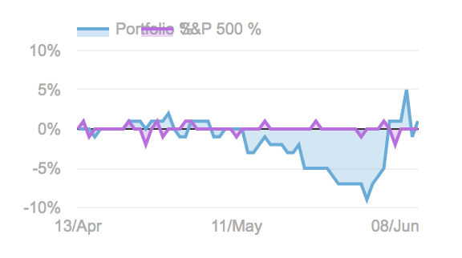

## Market Anomalies

### January Returns - ADBE

h0: returns in non January months (0) - ret in January (1) =0

ha: returns in non January months (0) - ret in January (1) <>0

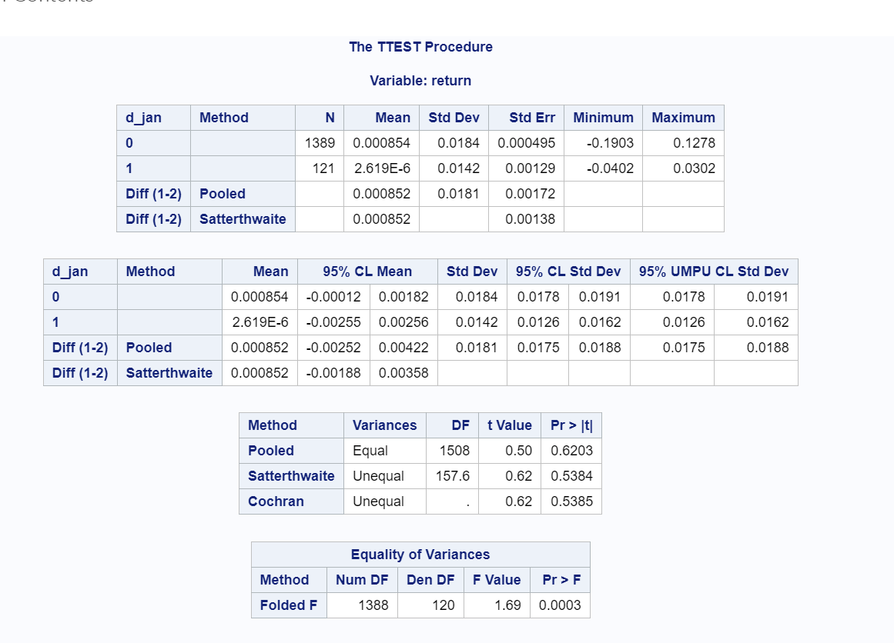Significance level: 95%

At a 95% significance level, we do not reject our null hypothesis. We don’t have enough information to conclude that returns in January are not greater than returns in other months

The potential implications of this result are that calendar anomalies are not as present for Adobe as they may be for other stocks. This may be because this anomaly is especially prevalent for small return firms, which Adobe is not. Because Adobe does not experience this anomaly, the month should not affect an individual’s decision about whether to buy or sell Adobe stock.

## Portfolio Optimization

Our optimal portfolio is based on three of our five stocks because the two newest do not have enough historical data to perform the analysis.

### Global Minimum Variance

Our global minimum variance model provided the following weights, standard deviation, and return:

|  |  |
| --- | --- |
| SBUX | 0.45174883 |
| ADBE | 0.25686267 |
| JPM | 0.2913885 |
| Min. Var. Portfolio STD | 0.02567401 |
| Min. Var. Portfolio Return | 0.003595 |

Based on this optimal minimum variance model we would go long on each of these three stocks. The expected portfolio return is 0.36% with a portfolio standard deviation of 0.02567.

### Tangent Portfolio

In this model we would invest in SBUX and ADBE and short JPM. This investment would give us an expected weekly return rate of 1.3% and a standard deviation of .05222. This portfolio has an optimized Sharpe Ratio of 0.239. This portfolio would give us the highest Sharpe Ratio.

|  |  |
| --- | --- |
| SBUX | 1.04426839 |
| ADBE | 1.32039117 |
| JPM | -1.3646596 |
| Optimal Portfolio STD | 0.05221752 |
| Optimal Portfolio Return | 0.01306156 |

### Efficient Frontier

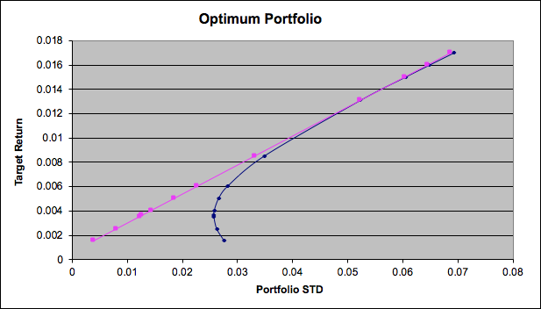

## Reflection

Our investment strategy was partly a success because we had a positive return. However, we could have diversified our portfolio more and increased our return potential. We made some emotional trades based on the fact that our team is very risk averse and most ended up backfiring. On the other side, some stocks in our portfolio gave us a huge amount of return, but that was mostly due to luck. We could have researched other sectors and applied the analysis we learned this quarter to select better stocks before we added them to our portfolio. Instead, much of our analysis of the stocks happened after we had already purchased the stock.

Our decision to choose recently IPO’d stocks meant that we should have been more vigilant about checking the status of the market and price fluctuations many times a day. These stocks could vary wildly within one day, and because we were unable to keep up with these changes to buy or sell at the perfect time, we missed out on a much higher return. Overall, this investing simulation project helped us learn about the process of investing and provided us with tools so that we can find the right stocks based on our interests, goals, and risk tolerance.

## References

1. Adobe Fast Facts; https://www.adobe.com/about-adobe/fast-facts.html
2. Our Businesses; https://www.jpmorganchase.com/corporate/About-JPMC/client-solutions.htm
3. Financial Highlights; https://www.jpmorganchase.com/corporate/investor-relations/document/financial-highlights-2018.pdf
4. Starbucks Company Profile; https://www.starbucks.com/about-us/company-information/starbucks-company-profile
5. *Eat dirt, Uber! Beyond Meat is most successful IPO of 2019 so far* by Min, Sarah; https://www.cbsnews.com/news/beyond-meat-ipo-most-successful-initial-public-offering-of-2019-so-far/
6. *Beyond Meat goes public with a bang: 5 things to know about the plant-based meat maker* by Linnane, Ciara; https://www.marketwatch.com/story/beyond-meat-is-going-public-5-things-to-know-about-the-plant-based-meat-maker-2018-11-23
7. *Opinion: Pinterest’s IPO filing: 5 things investors should know* by Poletti, Therese; https://www.marketwatch.com/story/pinterests-ipo-filing-5-things-investors-should-know-2019-03-22
8. *Beyond Meat shares spike another 14%, leaving Uber in the dust after IPO* by Imbert, Fred; https://www.cnbc.com/2019/05/14/beyond-meat-shares-spike-another-14percent-leaving-uber-in-the-dust-after-ipo.html
9. Quantitative Investment Analysis 3rd Edition, Richard A.DeFusco, CFA. Dennis W.McLeavey, CFA. Jerald E.Pinto, CFA. David E.Runkle, CFA. , Copyright 2015